

**Wirral Hospitals’ School**

***“Working together to make everything better”***

**An Ofsted “Outstanding” School**

**Headteacher: Mr P Arrowsmith**

Joseph Paxton Campus, 157 Park Road North, Claughton, Wirral. CH41 0DD

Tel: 0151-488-7680 Fax: 0151-653-8342

e-mail: [schooloffice@wirralhs.co.uk](mailto:schooloffice@wirralhs.co.uk) Website [www.wirralhs.co.uk](http://www.wirralhs.co.uk)

**Mobile Phone and Headphones Policy**

As part of our ongoing work regarding the safety and well-being of our young people, and in line with both recent research and new government policy briefings on this issue, we have reviewed our school policy regarding mobile phones and headphones in school.

In brief, students are allowed to bring mobile phones into school; however, **all phones must be switched off and out of sight at all times.** Students may be allowed to bring headphones into school, **but only if this is part of a package of support mechanisms as advised by specialist health professionals, such as CAMHS.**

The policy is enclosed, we ask that you read it with your child/ward and return the **Mobile Phone and Headphones Agreement** once it is signed (White Document).

If you have any further queries, please do not hesitate to contact your childs House Team as listed below:

Green House - Helen Marshall and Anthony Thompson

Blue House - Carol Bimpson and Louise Bell

Yours sincerely

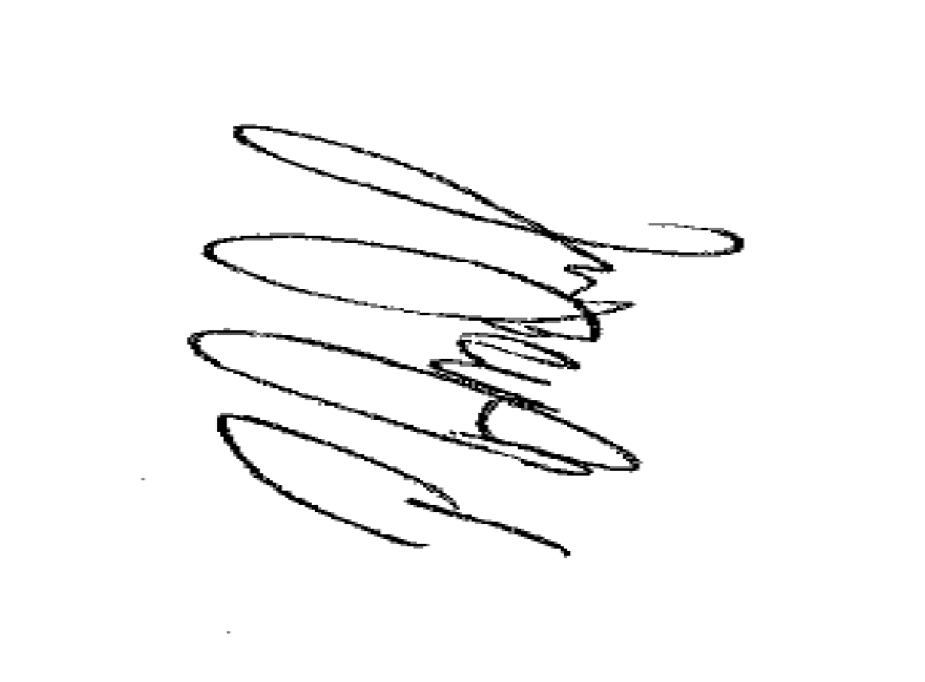

Phill Arrowsmith

Headteacher

Mobile Phone and Headphones Policy

Over recent years there has been a huge culture shift regarding mobile phones, especially smart phones. They are used by the general public as a useful tool for much more than just making phone calls. However, national and international research is now providing **conclusive evidence of the dangers of mobile phone use for children and young people**. These dangers are not only to their emotional health and wellbeing, but also to the physiological development of the growing brain. In addition, there is strong evidence to suggest that mobile phone use is detrimental to the ability of students to learn new information or complete complex tasks.

The aim of the policy is to be direct and precise. The abuse of the privilege to have mobile phones and headphones in school will have clear and direct consequences.

Policy Objectives:

* All phones, headphones, ear pods, etc. must be switched off and put away before entering the building each day and must remain switched off and out of sight for the duration of the school day – 8.30am to 3.30pm.
* Mobile phones are not allowed to be used by any student (or any member of staff) at any time, or for any reason, during the school day.
* The permission to listen to music through headphones can only be given by the Headteaher upon recommendation of a specialist medical professional. In these exceptional circumstances, headphones will be allowed during wellbeing breaks from lessons. Headphones are not allowed in lessons or during private study sessions.
* Where students have permission to use headphones, these must be kept out of site unless they are being used during a wellbeing break.
* Students cannot use a mobile phone in an exam – even as a calculator (as per exam board regulations). Mobile phones are collected by exam invigilators prior to every public exam and are kept safely locked away until the exam finishes. Students must always hand their phone in during an exam or leave it at home.
* Students who have permission to use headphones during wellbeing breaks, will be provided with school headphones during external exams to use as part of any rest breaks. Students must not take their own headphones into the exam hall.
* Students must **NEVER** take photos or film in or out of the classroom on a personal phone (it can be a criminal offence and will be dealt with severely). Contact with Parent/Carer will be made on any such occasion.
* Outside of school, students must not use their phones and/or social media, to cause upset to another student or to continue with any conflict that has arisen. All such issues must be brought to that attention of school staff, who will support students in resolving these issues.
* Any bullying or harassment received via mobile phones and/or social media must be brought to the attention of school staff, who will advise blocking/deleting specific students who are causing the upset. If a student refuses to block/delete the other person/people, the issue becomes the sole responsibility of the parent(s) and school will take no further part in resolving the disputes. In all such instances described above, a member of school staff will contact home to discuss the issue. In extreme cases, where the issue could be viewed as bullying or harassment, we will always advise families to report the issue as a crime to the police and the child’s placement at WHS will be immediately reviewed.
* Students MUST NOT contact home from their mobile and arrange to go home.

If a student is ill, they MUST see the House Team or a member of the SLT. The only way any arrangement with home can take place is through the school.

* Parents MUST NOT contact students directly on their phones for any reason. All contact during the school day should be made via the school office.

CONSEQUENCES

If at any point a student is seen using their phone during the school day, it will be confiscated for the remainder of the day, kept in the school safe, and handed back to the child when they are leaving to go home.

For repeated offences, the confiscated phone will not be returned to the child. In these circumstances, the parent or carer will need to come to school to collect it.

Repeated misuse of a mobile phone and/or headphones will result in them being handed in at the school office each day and only given back to the student at the end of the day. Ultimately, individual students may be banned from bringing their phone/headphones to school.

Repeated instances of failure to adhere to these rules and/or inappropriate behaviour on social media may result in the termination of the student’s placement at Wirral Hospitals’ School.

DISCLAIMER

Students are not required to have a mobile phone in school and we support parents who make the decision that this is not necessary by ensuring that students are able to use school landlines to contact parents in an emergency. Parents can, of course, contact school via the school landline.

This policy does, however, recognise that the majority of our students do own a mobile phone. Any student who brings a mobile phone and/or headphones into school does so at their own risk and school will not be held responsible for any loss or damage.