**At JPC we do not have a school uniform.**

****Clothes that are worn for school do need to be suitable for a variety of school activities and not distract from learning. Even when it is very hot weather we ask that students wear our ‘acceptable’ suggestions of clothing.

**For example:**

Flat shoes, suitable for physical activity; PE, a walk in the park or around the school grounds, gardening, drama activities. Long t-shirts and long shorts.

**Upper Garments:**

Cover shoulder to shoulder. No rips or tears.

Tops should be long enough to be tucked in. No halter necks, tube tops, crop tops or camisoles.

**Lower garments:**

Shorts must be mid-thigh or lower.

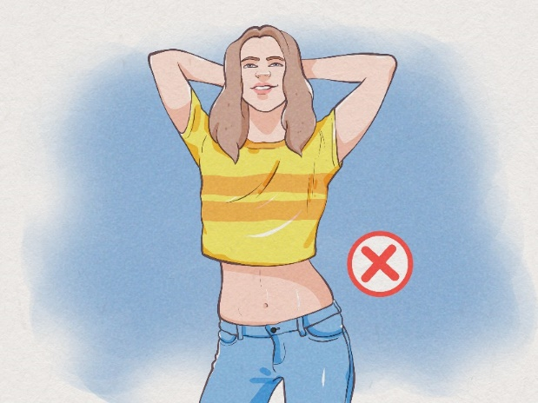Skirts should not be too short.

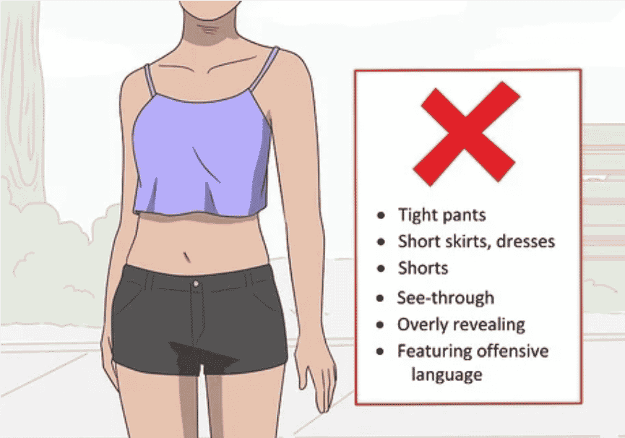

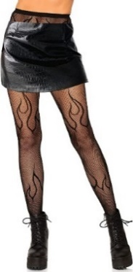





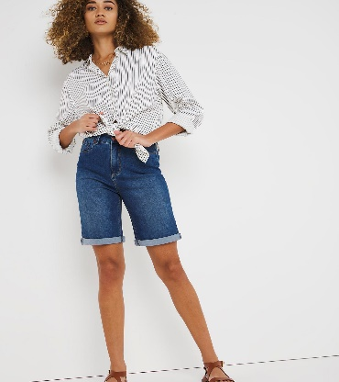



**Footwear:**

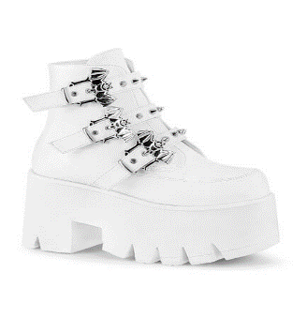Open toe and platform heels are not safe footwear for school

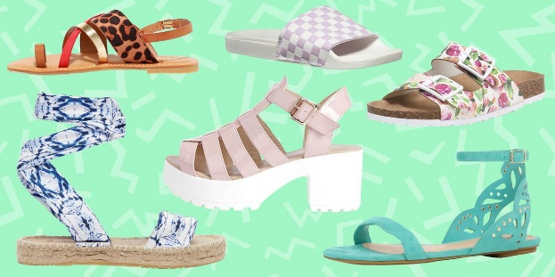

**Clothes and your individuality**

At JPC we celebrate everyone’s individuality. By not having a fixed school uniform students’ can express themselves more freely than in a school with a uniform. We are a school for learning and some items of clothing are not suitable for all of our activities.

You are allowed nail varnish, coloured hair and piercings. However, nails should not be too long so you can type and write.

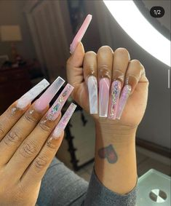 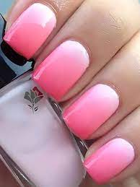

Jewellery that is sharp can be a risk in some school activities.

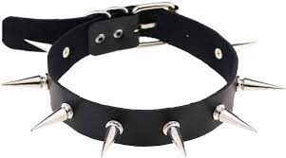

****We realise that without a fixed uniform may of our students want to follow fashion trends. These trends are not always suitable for school wear. These images are meant as a guide only. If you are not sure if an item of clothing is suitable for school or the day’s activities please contact your House Team.

If you repeatedly turn up in inappropriate clothes, you will be given school clothing to wear.