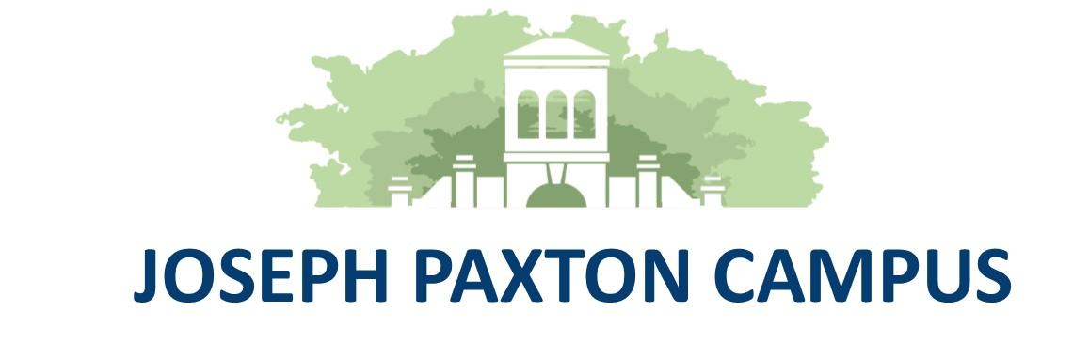
Wirral Hospitals’ School
“Working together to make everything better”
An Ofsted “Outstanding” School

Headteacher: Mr P Arrowsmith

Joseph Paxton Campus, 157 Park Road North, Claughton, Wirral. CH41 0DD
Tel: 0151-488-7680
e-mail: schooloffice@wirralhs.co.uk Website www.wirralhs.co.uk

March 2024

Dear Parents/Carers,

You may have noticed an unusual addition to the grounds of Wirral Hospitals’ School!
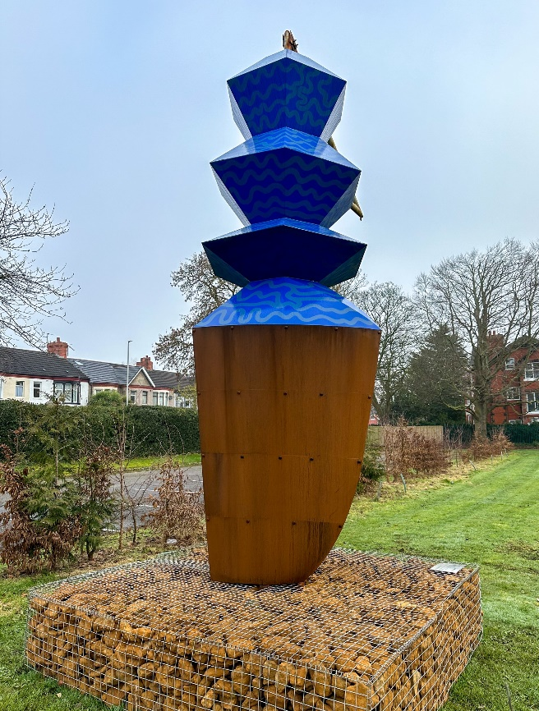
This ‘Totemy’ sculpture is a gift from the artist Alicja Biala and The Liverpool Biennial. This is as a result of students at Wirral Hospitals’ School being involved over 2 years in a project looking at the impact of climate change on the Liverpool City Region, one of the areas most at risk from rising sea levels caused by climate change.

The sculpture was one of 3 ‘Totemy’ that were on public display outside the Liver Building for the last 2 years.

You can find out more about the sculptures, the project, the artist and the Liverpool Biennial at the following links:

https://www.biennial.com/artists/alicja-biala/

https://www.biennial.com/alicja-bialas-monumental-public-artwork-merseyside-totemy-unveiled-at-liverpools-pier-head/

https://www.biennial.com/alicja-bialas-merseyside-totemy-to-undergo-exciting-transformation/

You can also find out about the risk of rising sea levels in this area by scanning the qr code for lots of information.
