
Wirral Hospitals’ School
“Working together to make everything better”
An Ofsted “Outstanding” School

Headteacher: Mr P Arrowsmith

Joseph Paxton Campus, 157 Park Road North, Claughton, Wirral. CH41 0DD
Tel: 0151-488-7680
e-mail: schooloffice@wirralhs.co.uk Website www.wirralhs.co.uk

3RD May 2024

Dear Parent/Carer

FOOD TECHNOLOGY CONTRIBUTION SUMMER TERM 2024

I am sure you have noticed the excellent quality of food that our students produce on a weekly basis, in Food Technology lessons. We are very keen for this to continue to happen.

Due to the continuing strain on school budgets that have affected all schools, we are asking that, similar to other schools, parents/carers make a voluntary contribution for the cost of the food that goes home. We are requesting the amount of £10 per student, per term which can be paid via SchoolSpider or to the Office. The funds raised will directly support the Food Department in purchasing ingredients used by your child to cook the food they bring home. The charge will be requested on a termly basis.

Additionally, we are asking that students bring in a clip/lock container that is large enough to take home the food that is produced in lessons. These are easily purchased from most supermarkets.
Here are some examples of these containers:
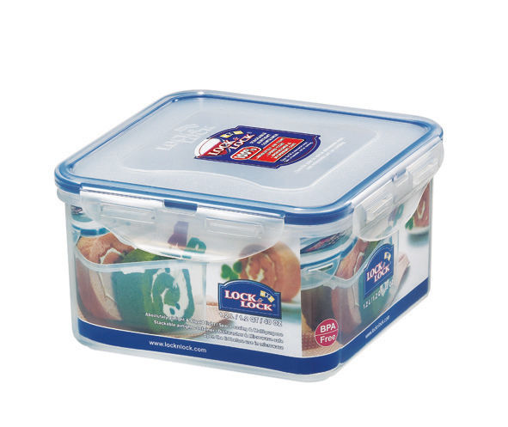
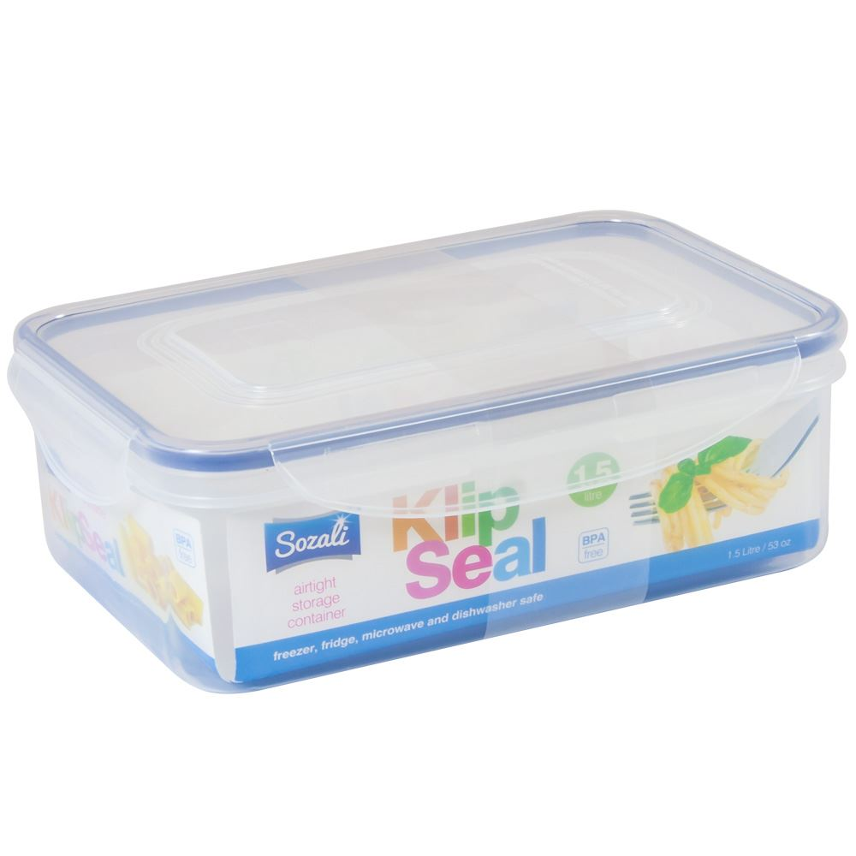

It is worth mentioning at this point, that there are still a core group of students who cook, but forget to take their foods home, this clearly is wasteful and not a good use of your/school funds. Please speak to your child/ward if they do not bring home the foods they have cooked and encourage them to do so.

Please complete the attached reply slip to acknowledge receipt of this letter.

If you have any concerns about this please do not hesitate to contact me.

Yours sincerely,

Mr Phill Arrowsmith
Headteacher

Wirral Hospitals’ School
“Working together to make everything better”
An Ofsted “Outstanding” School

Headteacher: Mr P Arrowsmith

Joseph Paxton Campus, 157 Park Road North, Claughton, Wirral. CH41 0DD
Tel: 0151-488-7680
e-mail: schooloffice@wirralhs.co.uk Website www.wirralhs.co.uk

Reply Slip for Food Technology Lessons
Summer Term 2024

I acknowledge the costings for Food Technology Lessons.

I enclose a £10 contribution / have paid online

Student Name: __________________________________________________________

Signed: ___________________________ (Parent/Carer) Date: ___________________

