 | Creative | Relaxation | Sporty
MON | Music  Stephen  F1  Coding Club  Joe  F9 | Gardening/Eco  Shaun  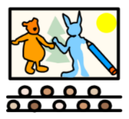  Meet in G19  Anime Club  G18  Anthony & Paul | Seasonal Sports  Callum & James  Hall/MUGA
TUES | Computer Games Club  F11  Anthony  Film and Editing  F1  Luke | Chill Out Club  Louise & Julie  G19 | Learning for Life  Terence & Paul  Meet in the Hall
WED | Craft  Helen & Julie  G19  Cooking  Loraine & Louise  G13 | Board Games  Carol & Jeanette  G19 | Seasonal Sports [LFC]  Callum & Louis  Hall/MUGA
THURS | Music  Mrs Steff & Stephen  F1  Art  Mr McMillan & Shaun  F7 | Bike ride  Terence & James  Meet in the Hall  Chess Club  G19  Joe | Running  Mrs Kingan & Becky  Meet in the Hall

