Headteacher’s Report to Governors
Spring 2021
School Context + Admissions
There are currently 80 students on roll, broken down as follows:
Year 11 = 31; Year 10 = 26; Year 9 = 16; Year 8 = 7; Year 7 = 0
We have now completed the three of our six admissions panels this year, with the January one having to be cancelled due to lockdown. At our latest admissions panel we admitted 14 new students out of just 15 referrals. This shows the improved quality of referrals as a result of the early intervention and consultation work I now offer all schools. There was a significant concern raised about the quality of the fifteenth referral, and this school’s lack of engagement in learning about our school and the admissions process. This has been discussed at the admissions panel meeting and passed over to the LA.
Exclusions / Placements Ended
The above student numbers includes three students who are awaiting alternative education arrangements. Two are waiting for Home Education, one is being helped to apply for a package of Education Other Than At School, via the EHCP process. Therefore, the current total number of students expected to attend is actually 77, with two admissions panels to go.
There have been no fixed term exclusions this term or last term.
Attendance
Term | 2018-19 | 2019-20 | 2020-21
Autumn | 78% | 80% | 70%**
Spring | 77% | 75% | N/A*
Summer | 80% | N/A*
Overall | 78.3% | N/A*
*Note: Due to Covid-19 and the subsequent lockdown measures, there are no relevant attendance figures for the summer term 2020 or the Spring term 2021.
** Note: Clearly this is a low figure and one that concerns us all. However, to put it into context, there are areas of the North West where the attendance figures for mainstream schools are as low as 61%. In addition, this figure includes the four students mentioned above, all of whom are on 0%, a student who was on 0% following a SEND tribunal and who has now moved schools, and several new students who are currently on phased transitions. Of note is that the vast majority of students have attendance above 80% for this term, with 16 of the 56 students who started the year having attendance of over 95%.

Health and Safety
There have been no significant incidents or accidents of a health and safety nature during this term or last.
The MUGA carpet has been renovated and restored during February half term and is looking in excellent condition. It is now available for use, both for JPC lessons and activities, and for community rentals.
High Needs review and National Funding
We have still yet to receive any response from the LA to our query about the decision to withhold the entirety of the government’s 8% uplift for hospital schools. In addition, we are yet to be offered any kind of meeting to discuss our deficit budget situation. However, at least partly as a result of Covid, our financial position is more positive and so it is understandable that we are not currently a priority for these discussions.
An interim LA manager has been appointed on temporary basis to review the various High Needs reviews that have taken place in recent years. He is communicating effectively with all Headteachers’ groups at the moment. Part of his work is to discover more about how and why the recommendations from previous reviews have not been followed through, either by the LA or by Wirral councillors.
Catch Up Premium
Blended Learning - This part of the fund has been spent in its entirety. The result of this is that we have a fully functional blended learning programme in place, with most students engaging with online lessons, at least so some degree. This is to become our normal way of working with students who are unable to access the full curriculum at JPC. For the remainder of this term, teachers are planning face-to-face lessons as well as providing online tasks and activities for the students who are not in school or lessons. After Easter, rather than doing this for all lessons, it will done on an individual basis, following requests by the House team or SEND team. By taking this approach, we hope to be able to maintain placements for students who are struggling to attend the building. A blended approach of online lessons, along with visits to key staff, will hopefully maintain that relationship with us and help overcome the barriers to attendance. We believe that this represents a significant improvement for some students, rather than simply soldiering on, or referring on to Home Education.
Increased Inference Training – Clearly, our effectiveness in this area has been significantly hampered by the lockdown in January. I will be meeting with JAH after Easter to review the work already completed and plan a way forward that provides widest reach and best value for money.
Coronavirus
We have had no further reports of positive cases since the last Headteacher’s report to governors. Home testing kits are available to all staff and students who wish to participate. So far, 13 staff and 46 students have opted into this regular testing programme. I have chosen not to do so.
All staff are wearing face coverings at all times when inside the building and with students. This was a request I made, rather than an instruction, in order to model best practice and to be fair to students, who have been instructed to wear face coverings at all times. We asked parents to provide a medical letter on this occasion for exemptions. I have been extremely disappointed in the response from Wirral GPs, who have all refused to provide a letter. However, the CAMHS service have been extremely helpful in this matter. So far, we have 12 students who have exemptions. We hope to be able to relax this ‘rule’ for lesson time after Easter but will, of course, be guided by government advice on all matters regarding the Health and Safety requirements for dealing with Covid-19.
SEND – AOP/PH
Social Thinking – Form Tutors are delivering materials written by Kirstie Goulding, which use social thinking concepts to develop understanding of the roadmap to coming out of Lockdown.

SALT – During Lockdown, Kirstie Goulding has completed the reports and care plans for all students she managed to assess before Christmas. Kirstie was able to work closely with Pauline Hoey to complete the SALT evidence needed for EHCP applications for transition to post 16 placements. Kirstie offered to work flexibly so that any days that were not used can be used now that we are returning to full time school and face to face assessment.

Autism Accreditation – Autism Accreditation contact has continued and we have reported our development of Remote Learning, based on the needs of learners with Autism and anxiety, including person-centred learning and awareness of difficulties with language, processing and executive function. Our preparation for student return was based on the need for increased predictability and preparation for change.
The process of preparation for the assessment review begins again this month with a virtual meeting and all of our good practice during the lockdown period will be shared with our advisor as part of our evidence portfolio.

Transition and EHCPs – The Year 11 Transition Programme has been difficult over the last year. Our students really need that experience of seeing the colleges, meeting the people that will support them and getting a feel for how it might be OK in a new setting. For many of them, thinking in the abstract is virtually impossible. For those that can imagine college life, it can be very anxiety provoking. We have many strategies to try to give them a sense of what to expect.
The colleges, particularly Wirral Met, have been very good at providing visual resources, virtual tours and virtual open evenings. We have been able to organise online meetings with families and students, and transition meetings with the colleges that have enabled us to give students some idea of what next year might be like, and the support available. A number of students this year have had multiple meetings as they explore different avenues. We have had 2 students explore residential pathways which has been a learning curve for ourselves as well as the student!
Our process of applying for EHCPs as students leave us has been different every year, as the Local Authority tries to manage the large number of applications we make. This year, they have let us work through the standard pathways so far. We have 6 students in Year 11 who have an existing EHCP. These were reviewed in the first half term (apart from one student who is currently very unwell). We have applied for 16 students to have an EHCP assessment. 6 of these have been agreed to be assessed and are now in that process. We are waiting to hear on the remaining 10. We have 2 more students we will have applied for by the time you read this and 7 students still awaiting transition meetings. The remaining 7 may not need EHCPs - this will be decided at their meetings.
We hope the transition meetings will lead to further contact between the student and the people who will support them next year. We continue to hope there will be opportunity for them to visit colleges before the summer so they are well prepared for September. It is a very challenging time to be a Year 11 student.
NAHE - AOP has continued to participate in the NAHE SENCO cluster group and attended the online meeting in February and will contribute to the next meeting in May 21.

Teaching Assistants - The teaching Assistant team engaged in all remote learning training. They have responded very positively to the demands of supporting students through remote learning – sending out engaging, special interest-related activities and keeping positive interaction with their key students during lockdown. A small number of students who could not manage any formal learning through the main curriculum were able to remain engaged through this approach and this enabled them to successfully return to school in the first week back.

Safeguarding – Vicki Tranter and Jackie McArdle
Carol and I attended this Surviving to Thriving Webinar on behalf of the school, see details below.

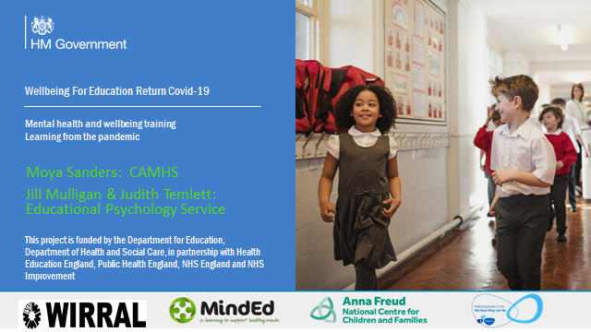

As a result, Clare has started the staff "Wellbeing" notice board on google classroom and is posting information in chunks to the staff. Also Mentors have been doing Wellbeing as part of their LFL lessons. In order to help find a balance between school life and home during this pandemic.

The first of two webinars is about the whole school approach to staff wellbeing.
- To recognise the effects of the pandemic on everyone’s well-being.
- To look at the importance of looking after our own wellbeing so that we can support others.
- To learn how to support individuals who may be finding circumstances more difficult than others through using the Psychological First Aid model.
The second webinar is about addressing the needs of those who are having particular difficulties related to the pandemic such as loss, anxiety, low mood. It will explore strategies that you can use for everyone.
- Dealing with loss.
- Dealing with anxiety and low mood.
- Dealing with stress and trauma.
Curriculum and Extra-Curricular News and Celebrations
Sadly, since the last Headteacher’s report, we have still not been able to re-start our normal extra-curricular activities and trips. Therefore, there is very little to report, other than to say that Learning for Life staff have begun taking students back into Birkenhead Park for activities and wellbeing walks.
Music – S Steff
In the music department: Connor has been giving some instrumental lessons to support students who have been struggling to engage with their online learning and this has had a very positive outcome for those students.

Personal achievement: I have recently found out that I have passed my NPQML leadership qualification which has been awarded through Chester University. My Focus project was helping to lead on the implementation of the Arts Award which has proven to be a great extra qualification for lots of our students.

Arts Award: For part of the Arts Award qualification, we are currently preparing a concert for the students which will be performed by some staff members.
We are really looking forward to all the students returning so we can engage in our full music curriculum.
Food Tech – P Balfour
We have recently made the move from BTEC Home Cooking to GCSE Food Preparation and Nutrition.

This is a much more challenging course, and we have 3 students fast-tracking through it, doing really well, despite lockdown! Their practical assessments fortunately happened pre-lockdown and were very highly graded. Big thanks to Loraine Lewis for her incredible support during practical exams, I/students literally couldn't do it without her and she is not allowed to retire any time soon ! 🙂. Her ability to calm and settle nervous students is exceptional and her ability to informally support practical work is superb.
Art – R McMillan
During lockdown, students at WHS have been busy designing and painting a new mermaid to be located in Vale Park, New Brighton. The mermaid forms part of the mermaid trail and will replace the previous WHS mermaid that sadly succumbed to a fire. The mermaid is designed in line with the original brief that won the commission for WHS and we are all delighted with it!

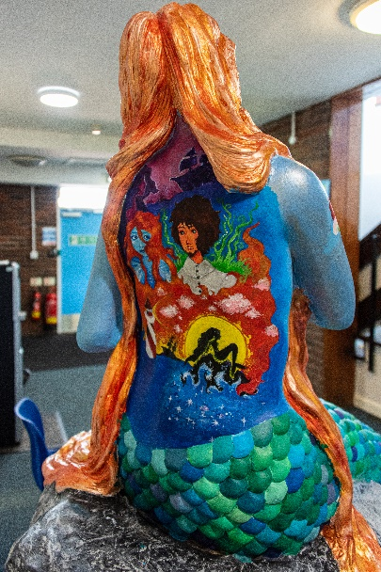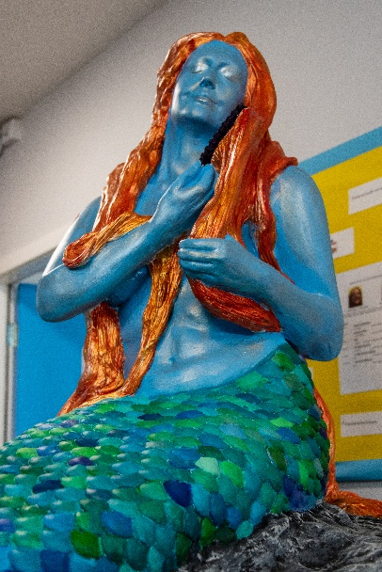

The Mermaid has now been completed and weatherproofed. We are just awaiting the collection and a new unveiling day.
English – C O’Meara
During lockdown we have continued to work on updating the library. We have new furniture, shelving, lighting and a whole host of new books with a range up to date factual texts; a wide selection of graphic novels and comic books and texts that reflect the diversity within our school population from LGBT+ to autism. Our KS3 students have also designed a series of book related posters that are now framed and add a splash of colour and joy to the space.

Next week we will be sending each of our students a link to a £1 voucher for World Book Day. They can then choose from a list of £1 books or put the voucher towards a book of their choice.

STEM Faculty – S Little
BTEC Science: After the success of implementing Google Classroom across the school during lockdown, we are now using the platform in Science for students to complete their BTEC coursework. It allows teachers to further personalise resources for students and provide clear, instant feedback for students to improve their work to meet the criteria required.
Elephant Maths: After the interruptions from Covid, our intervention programme, Elephant Maths, is already up and running again. Despite there being no external examinations in the summer, Yr11 students are still our priority. RK and MJB have identified a new cohort of students that we think will benefit most from the intervention, with a view to focusing on support for the assessments they will be taking to gather evidence for their attainment at GCSE level.
Science Week: Science week was supposed to be the week commencing 8th March. As Covid restrictions haven’t allowed us to hold an event the way we would have liked, we decided to postpone such an event until it is safe to do so. Our hope is that we will be able to hold a Science week whole-school event before the end of this academic year. We already have plans in place for a fully-funded planetarium to be set up in the hall, organised by RK.
Science Technician: We welcomed our new science technician, Jeanette Hale, before Christmas. She has settled well into the department and has already made our lives in the department easier by reorganising all of our practical resources within Science and ensuring everything is in line with current CLEAPPS guidance. She is eager to work with students when it is safe to do and is already looking for ways to integrate in different ways around school. Her enthusiasm is a welcome addition to our department.

I’d like to finish this report by saying how great it is to finally have our children back! School just hasn’t been the same without them! The gentle buzz of activity from having a ‘full’ school again has lifted the spirits of so many of us.
It is my strongest desire to ensure that we can move forward from here as a community, with no more lockdowns, and continue to do what we do best – Working Together to Make Everything Better!
P Arrowsmith Date: March 2021

